Chapter 10 Homework
Student’s Name
Institution Name

- In clear and concise terms, describe the structure of a chloroplast. Indicate the specific location inside a chloroplast where each of the following process occurs: light reactions that produce ATP & NADPH, Calvin Cycle that produces G3P.
Structure of chloroplast
Chloroplasts have biconvex or Plano-convex shape. The chloroplast is double membrane bound. They have a system of system of three membranes (inner, outer and thylakoid). The outer and inner membrane of the chloroplast enclose a semi gel like fluid called stroma, this makes the volume of chloroplasts and thylakoids system floats in the stroma(Glick, 2018).
Light reactions. This takes place in the thylakoids. Thylakoids contains important protein complexes which carry out light reactions of photosynthesis.
Calvin cycle. Takes place in the stroma.
- What is the primary equation of photosynthesis? What important role does water serve in photosynthesis? What is the source of electrons for the electron transport chain? What vital byproduct does water splitting produce?
The following demonstrate the primary photosynthesis equation
6CO₂+6H2O light energy C₆H12O₆+6O₂
Role of water in photosynthesis. Water provides hydrogen ions, oxygen and electrons which replace the lost electrons in photosystems II in photolysis. Hydrogen ions pass to ATP synthase to form ATP in light independent reaction.
Research has indicated that the source of electron for the electron transport chain is from water splitting and the vital by products from water splitting is oxygen which is later used in respiration.
3. In your own words, summarize how photosystems II and I convert light energy in photons to chemical energy in ATP & NADPH.
Photosystems
Photosystem II absorbs light, electrons are excited to a higher energy and trapped by primary electron acceptors. To replenish the deficit of electrons, electrons are extracted from water by a cluster of Manganese ions and supplied to chlorophyll via redox-active tyrosine. Photo excited electrons travel through the cytochrome complex to photosystem I via electron transport. The energy fall is used to transport Hydrogen ions to provide a potential energy difference between the thylakoid and the stroma which amounts to a proton motive force that can be used to generate ATP. The electrons continue to cyclic electron transport via ferredoxin, to enzyme NADP+ reductase (Glick, 2018). Electrons and Hydrogen ions are added to NADP+ to form NADPH.
4. Compare and contrast the movement of electrons in linear electron flow vs. in cyclic electron flow. What product(s) does each type of electron flow produce?
In linear electron flow, energy from absorbed photons is used to oxidize water on the luminal face of photosystem II (Lilley et al., 2015). Electrons generated by this process pass through a series of PS II and then oxidized to plastoquinones. Products formed in this is NADPH. In cyclic electro flow, energy from absorbed photons causes the oxidation of reaction centre in PS I.
5. Describe the similarities and differences between oxidative phosphorylation in mitochondria and photophosphorylation in chloroplasts.
Similarities
- Both are transferred through membrane proteins.
- In both electrons provide energy to pump protons to one side of the membrane.
- In both protons flow back through a special enzyme which makes ATP.
Difference
- Energy source for oxidative phosphorylation is glucose while in oxidative photophosphorylation the energy source is sunlight.
- Electron acceptor in oxidative phosphorylation is molecular oxygen while in photophosphorylation the final electron acceptor is NADP+
6. Define photorespiration and its consequences. What are the differences between C3 vs. C4 vs. CAM in terms of carbon fixation (spatial versus temporal separation), specifically where they are seen, types of plants, etc.?
Photorespiration is process in plant metabolism where enzyme RuBisCO oxygenates RuBP resulting to some of the energy produced by photosynthesis to be wasted.
C3 is a normal plant that does not have photosynthetic adaptations to reduce photorespiration eg soya beans (Lilley et al., 2015). In C4 plants, the light dependent reactions and Calvin cycle are physically separated for example sugarcane. In CAM plants, the plants are adapted to dry environments, they use crassulacean acid metabolism (CAM) pathway to minimize photorespiration.eg cacti.

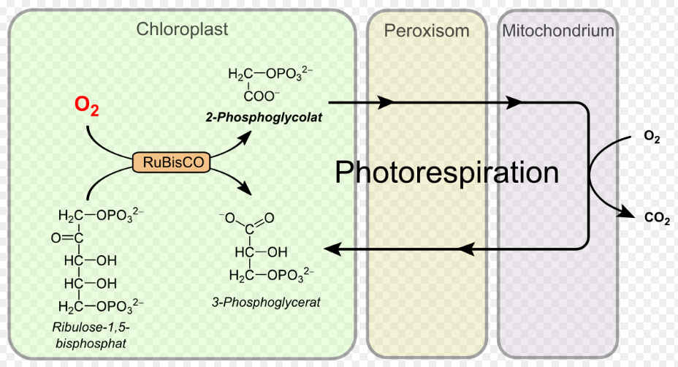
Figure 1: Photorespiration
Reference
Taylor, M. R., Simon, E. J., Dickey, J., Hogan, K. A., & Reece, J. B. (2018). Chapter 10. In Campbell biology: Concepts & connections (9th ed.).

